**Plotting bar and line graphs in R**

1. Create a data frame with two column as:

time total_bill

Lunch 14.89

Dinner 17.23

Then use and write functions to draw four graphs, respectively. (30 points)

(a)

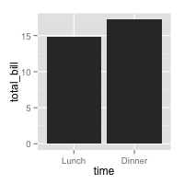

#**Creation of dataframe:**

library(ggplot2)

time <- c("Lunch", "Dinner")

total_bill <- c(14.89,17.23)

Bill <- data.frame(time, total_bill)

#Bill

ggplot(Bill, aes(x=time,y=total_bill)) + geom_bar(stat="identity")

(b)

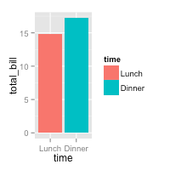

library(ggplot2)

time <- c( "Dinner","Lunch" )

total_bill <- c(17.23,14.89 )

Bill <- data.frame(time, total_bill )

ggplot(Bill,aes(x=time, y=total_bill, fill=time)) + geom_bar(stat="identity", **position="dodge")**

(c)

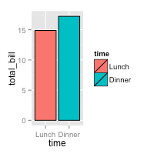

library(ggplot2)

time <- c( "Lunch","Dinner" )

total_bill <- c(14.89,17.23 )

Bill <- data.frame(time, total_bill )

ggplot(Bill,aes(x=time,y=total_bill,fill=time))+geom_bar(**colour="black",**stat="identity")

(d)

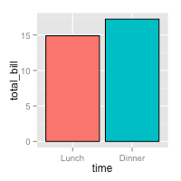

library(ggplot2)

time <- c("Lunch", "Dinner")

total_bill <- c(14.89,17.23)

Bill <- data.frame(time, total_bill)

ggplot(Bill,aes(x=time,y=total_bill,fill=time)) + geom_bar(stat="identity",position="identity",colour="black", size=0.25) +

scale_fill_manual(values=c("#33FFFF","#FB6A6A"),**guide=FALSE**)

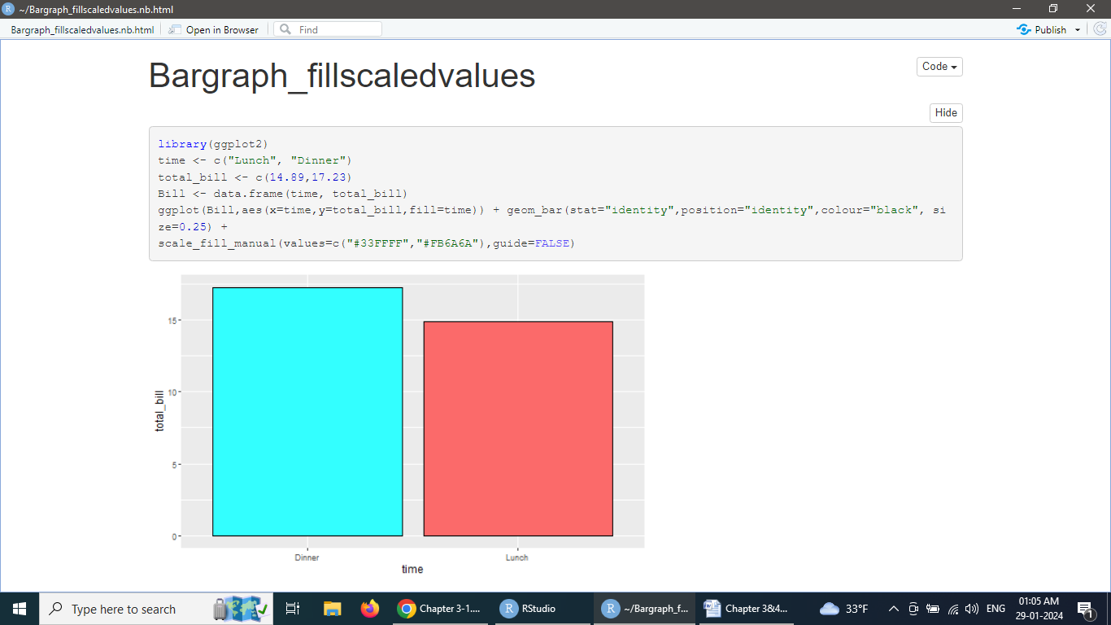

1. Create a data frame with three column as:

| sex | time | total_bill |
| --- | --- | --- |
| Female | Lunch | 13.53 |
| Female | Dinner | 16.81 |
| Male | Lunch | 16.24 |
| Male | Dinner | 17.42 |

Then use and write functions to draw four graphs, respectively. (30 points)

(a)

library(ggplot2)

sex <- c("Female", "Female", “Male”,”Male”)

time <- c(“Lunch”,”Dinner”,”Lunch”,”Dinner”)

total_bill <- c(13.53,16.81,16.24,17.42)

Bill <- data.frame(sex,time, total_bill)

#Bill

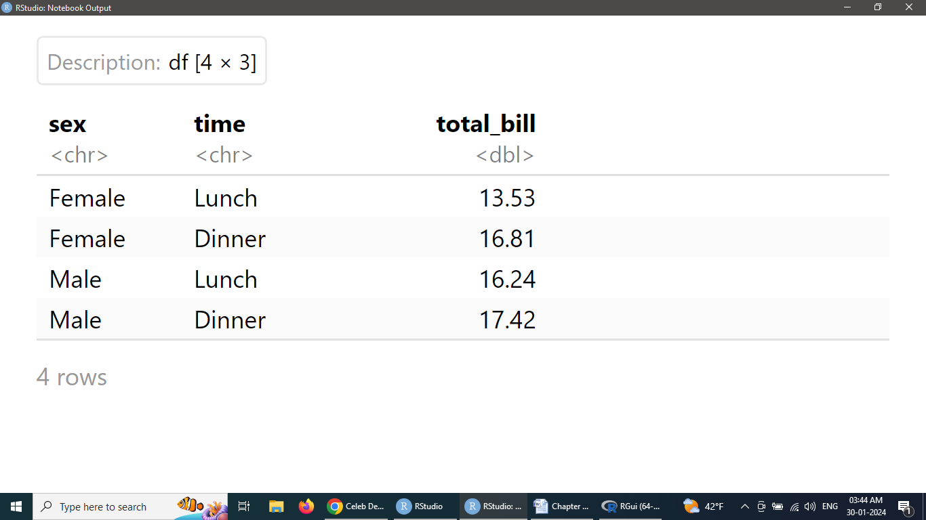

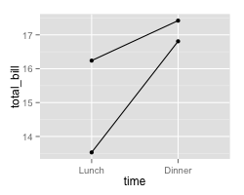

ggplot(Bill,aes(x=time,y=total_bill,**group=sex**)) +geom_line(size=1) + geom_point(size=2)

(b)

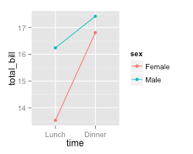

ggplot(Bill, aes(x=time, y=total_bill, group=sex, **colour=sex**)) +geom_line(size=1) +geom_point(size=2) #b

(c)

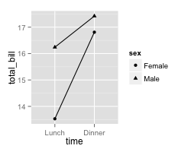

ggplot(Bill, aes(x=time, y=total_bill, group=sex, **shape=sex**)) + geom_line() + geom_point()

Executed result of above three codes:

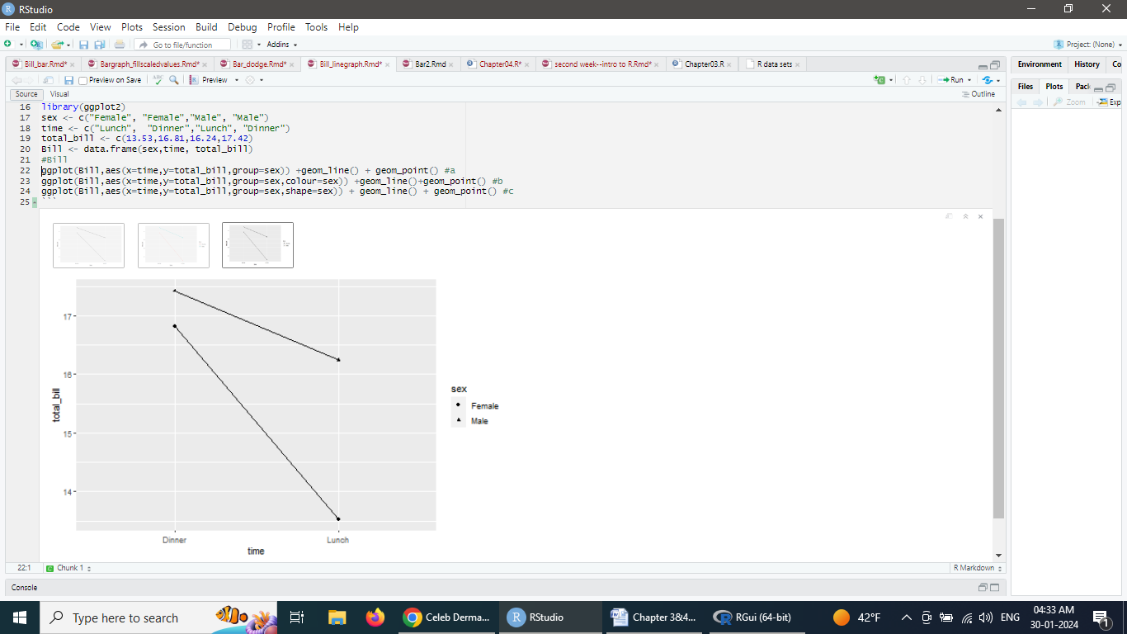

1. Use the data frame ToothGrowth to draw three graphs, respectively. (40 points)

install.packages("plyr")

library(ggplot2)

library(plyr)

tg <-ddply(ToothGrowth,c("supp", "dose"),summarise,length=mean(len))

(a)

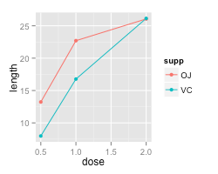

ggplot(tg, aes(x=dose, y=length, **colour =supp**)) + geom_line(size=1) + geom_point(size=2)#a

(b)

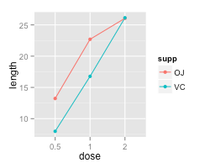

**tg1<- tg**

**tg1$dose<- factor(tg1$dose)**

ggplot(tg1,aes(x=dose, y=length, group=supp, colour=supp)) + geom_line(size=1) + geom_point(size=2)

(c)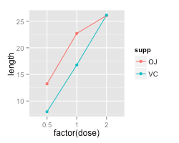

ggplot(tg, aes(**x=factor(dose**), y=length, group=supp, colour=supp)) + geom_line(size=1) + geom_point(size=2) #c

**Execution of the above codes and their results:**

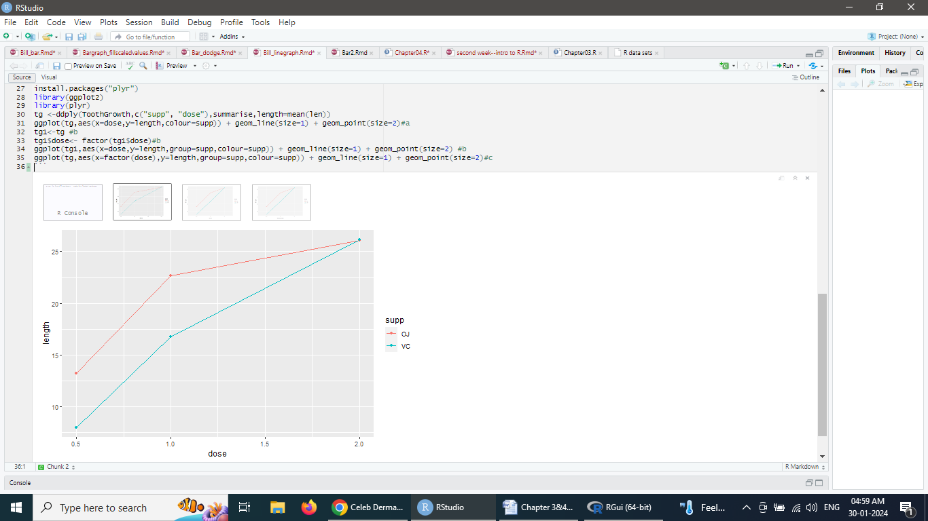

-----------------------------------------------------------END---------------------------------------------------------------